**Assignment 1**

1. ***Camera Calibration***

For camera calibration we used Matlab

We have taken images of a chessboard from the OKAD Lite camera at a distance of 44.4 inches in different positions.

After calibration of the images we got the parameters as shown

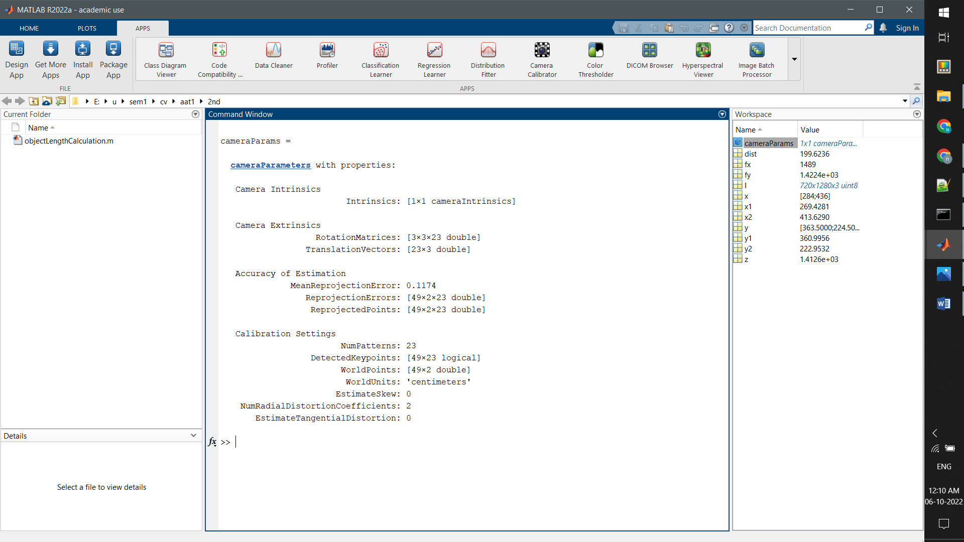

Calibration is finding the Intrinsic and Extrinsic parameters from the known 2d and 3d points. The rotation and translation matrices are important for the conversion of the 3d coordinates to 2d coordinates. These are calculated here.

Also fx, fy values are given in the intrinsic parameter.

***2.Object Length calculation***

I=imread('E:/u/sem1/cv/aat1/image13.jpg')

imshow(I)

[x,y]=ginput(2)

z=1412.6;

fy=1422.4;

fx=1489.0;

x1=z*(x(1)/fx);

x2=z*(x(2)/fx);

y1=z*(y(1)/fy);

y2=z*(y(2)/fy);

dist=sqrt((y2-y1)^2+(x2-x1)^2);

fprintf('The distqance is %.02f mm',dist);

Output:

***x =***

***282***

***434***

***y =***

***360***

***223***

***The distqance is 198.26 mm>>***

Here the actual side of the chessboard is 19.5 cm and the predicted value is 19.8 cm which is approximately same.

The images taken for this task is shown below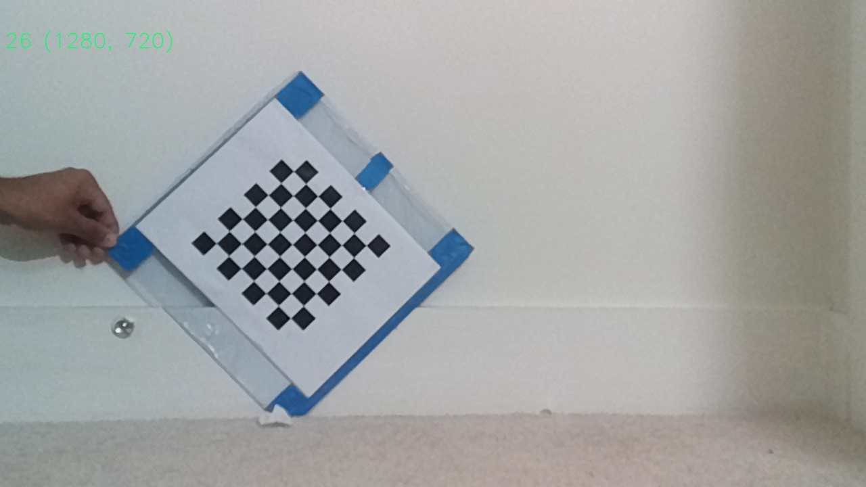

***3.RGB and Depth stream***

We can get both the depth and RGB streams at the same time and the maximum framerate and resolution for the RGB stream is 32 and 720p and 31 and 720 for Depth and together is 720p and 32fps.

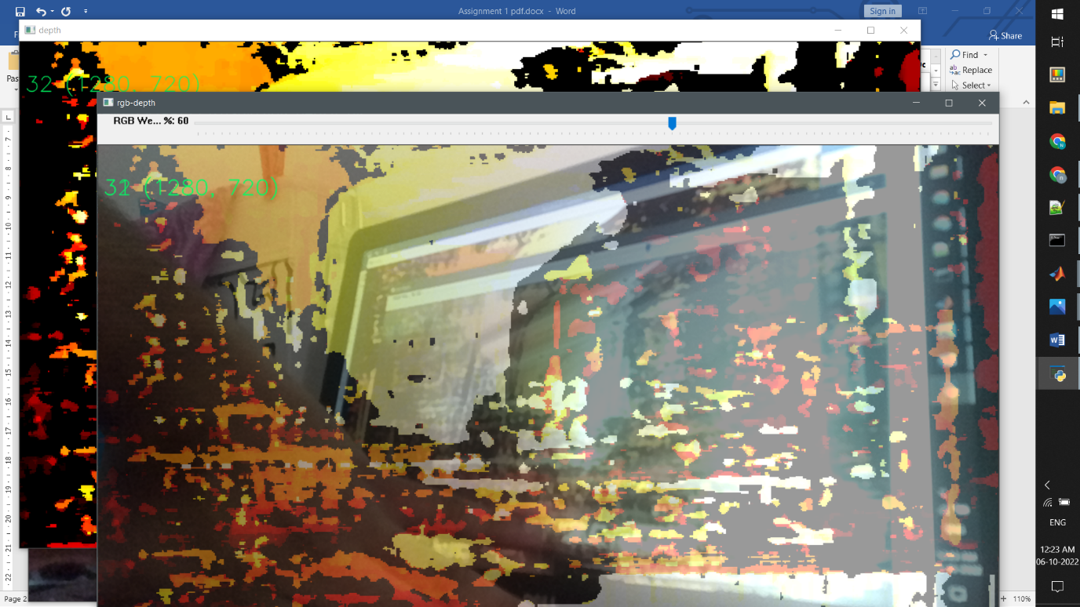RGB and Depth stream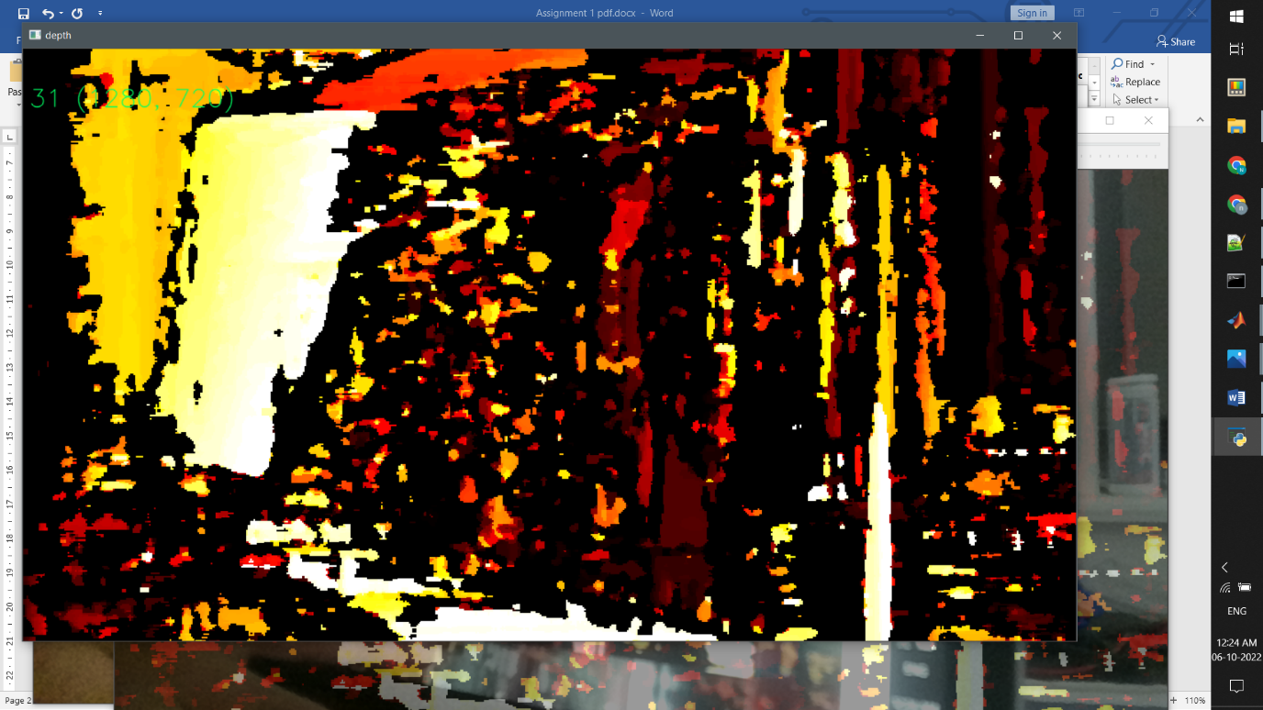

Depth stream

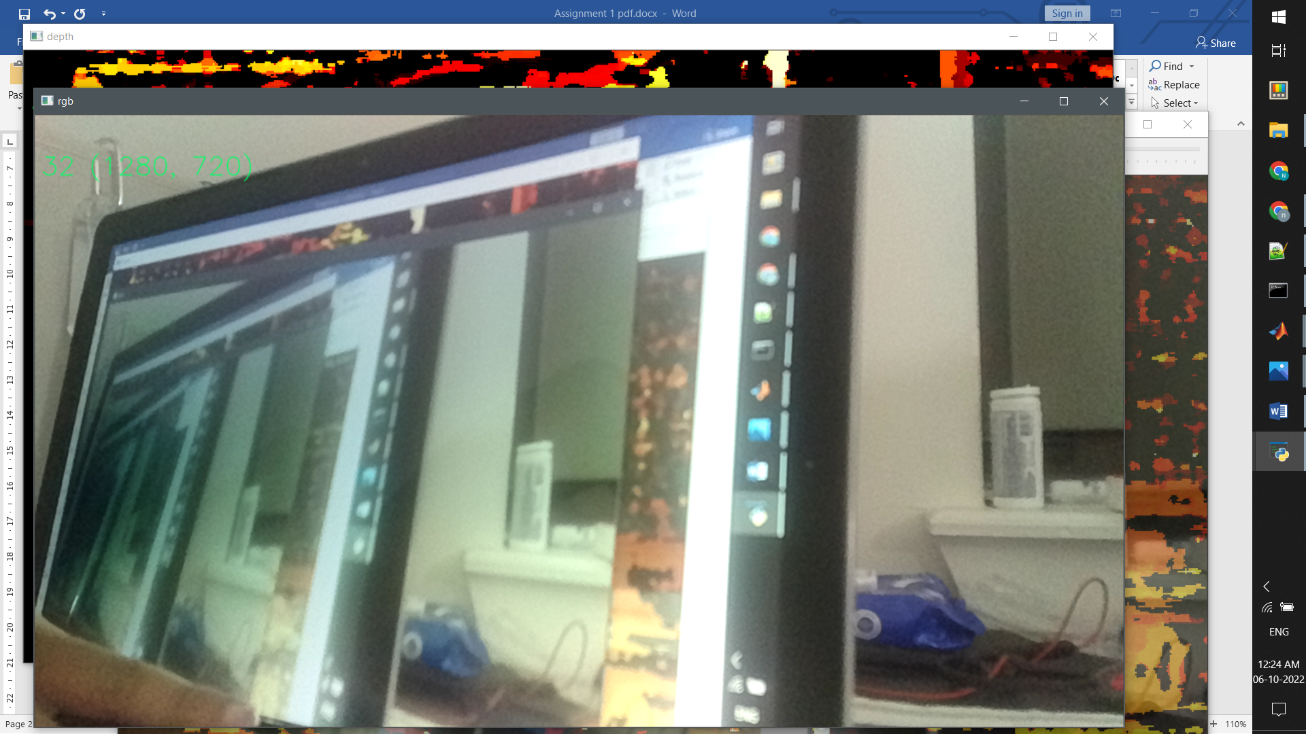

RGB stream

Video Link: <https://drive.google.com/file/d/1-iDWbCy8kcrEr3oIoQtIR3qHlfFAhJDj/view?usp=sharing>

Github Link: <https://github.com/NITIN0210/Computer-Vision.git>